**COMSATS University Islamabad,   
Abbottabad Campus**

**Home Assistant**

Version 1.2

***By***

**Faizan CIIT/FA21-BSE-011/ATD**

**Fawad Iqbal CIIT/FA21-BSE-012/ATD**

***Supervisor*Prof. Syed Shahab Zarin**

***Bachelor of Science in Computer Science (2024-2025)***

| **No.** | **Comment** | **Action** |
| --- | --- | --- |
|  |  |  |
|  |  |  |
|  |  |  |
|  |  |  |
|  |  |  |
|  |  |  |

**SCOPE DOCUMENT REVSION HISTORY**

**Supervisor Signature**

**Date:**

**Table of Contents**

**Abstract** 4

1. Introduction 5

2. Problem Statement 5

3. Problem Solution for Proposed System 5

3.1. Solving Everyday Problems: 5

3.2. Customization and Learning: 6

4. Related System Analysis/Literature Review 6

5. Advantages/Benefits of Proposed System 7

5.1. Benefits of Our System: 7

6. Scope 7

7. Modules 7

7.1. Modules for the proposed project: 7

8. System Limitations/Constraints 8

9. Software Process Methodology 9

10. Tools and Technologies 9

11. Project Stakeholders and Roles 10

12. Team Members Individual Tasks/Work Division 11

13. Data Gathering Approach 11

14. Concepts 12

15. Work Breakdown Structure (WBS) 13

16. Gantt chart 13

16.1 Excel 13

16.2 Microsoft Project 14

**17. Mockups** 15

18. Conclusion 17

**References** 17

**Project Category: (**Select all the major domains of proposed project**)**



**Abstract**

Our project aims to create a Home Automation System that lets users control household devices like fans and bulbs using their smartphones. Through a special mobile app, people can remotely manage their appliances, making their homes more convenient and energy efficient.

We're using innovative IoT technology, including Arduino microcontrollers and sensors, to make this happen. The sensors track humidity and temperature, providing accurate data for better home management. With our system, users can enjoy a smarter, more comfortable living space at their fingertips.

# 1. Introduction

This document is all about explaining our project idea for a Home Automation System. The purpose is to share our plans and get approval to move forward with development. Home automation is about making life easier by controlling things like lights and fans from your phone.

Our system uses special technology called IoT, which connects devices together through the internet. We're using Arduino, which is like a tiny computer, to make it all work. The system also has sensors to measure things like temperature and humidity, helping users manage their homes better. This proposal gives a detailed background on how we'll create this system and what it can do to improve everyday living.

# 2. Problem Statement

* Our software makes it easy to control things like fans and lights from your phone.
* We're making this system because it can be annoying to always have to get up to adjust appliances.
* While similar systems already exist, making our own version helps us learn more.
* We'll get better at using special technology called IoT, which connects devices together.
* Also, we'll learn how to work with small computers called Arduino, and how to use sensors to measure things like temperature and humidity.
* Plus, we'll get practice making mobile apps for Android and iPhones.
* Overall, this project helps us learn a lot of useful skills for building cool stuff in the future.

# 3. Problem Solution for Proposed System

## 3.1. Solving Everyday Problems:

* **Convenient Solution:** Manage home appliances easily with our mobile app.
* **Effortless Control:** Eliminate the need for constant physical interaction.
* **Remote Adjustment:** Adjust settings from anywhere with just a tap on the app.
* **Time and Energy Saving:** Save time and energy, ensuring comfort and convenience.
* **Promoting Energy Efficiency:** Easily monitor and control appliances for sustainability.

## 3.2. Customization and Learning:

* **Tailored to Preferences:** Customize the system to meet specific needs and preferences.
* **Hands-on Experience:** Gain valuable experience with IoT technology.
* **Seamless Integration:** Learn to integrate devices and create seamless communication channels.
* **Understanding Hardware Integration:** Work with Arduino microcontrollers and sensors.
* **Future Innovations:** Pave the way for future innovations in home automation.

# 4. Related System Analysis/Literature Review

| Application Name | Weakness | Proposed Project Solution |
| --- | --- | --- |
| SmartThings | Limited compatibility with devices | Our proposed project offers flexibility by allowing users to customise and integrate various devices through Arduino. |
| Google Home | Relies heavily on internet connection | Our system provides offline functionality through direct communication with Arduino microcontrollers, ensuring reliability. |
| Apple HomeKit | Limited support for non-Apple devices | Our project ensures compatibility with a wide range of devices, regardless of brand, offering users more options and flexibility. |

# 5. Advantages/Benefits of Proposed System

## 5.1. Benefits of Our System:

* **Easy to Use:** Control home devices from your phone without getting up.
* **Energy Saving:** Manage appliances remotely to save energy and money.
* **Personalization:** Customise the system to suit your home and lifestyle.
* **Home Monitoring:** Sensors keep you informed about your home's temperature and humidity.
* **Enhanced Security:** Remote control of lights enhances home security.
* **Scalability:** Start small and easily expand the system as needed.
* **Universal Compatibility:** Works with both Android and iPhone devices for everyone in the family.

# 6. Scope

Our project aims to develop a Home Automation System with a user-friendly mobile app interface, enabling remote control of household appliances. Key functionalities include on/off control, settings adjustment, and environmental monitoring through integrated sensors. Built using Arduino microcontrollers, the system prioritises customization, energy efficiency, and seamless operation across both Android and iOS platforms.

# 7. Modules

## 7.1. Modules for the proposed project:

1. **User Authentication:**

* This module manages user authentication and authorization, ensuring secure access to the system.
* Users will be required to register and log in to the mobile app using their credentials.

1. **Device Control:**

* The Device Control module enables users to remotely control various household appliances connected to the system.
* Users can turn devices on/off, adjust settings (e.g., brightness, speed), and set schedules for automated operation.

1. **Sensor Integration:**

* This module facilitates the integration of sensors for monitoring environmental conditions such as temperature and humidity.
* Real-time data from sensors will be displayed in the mobile app, allowing users to stay informed about their home environment.

1. **Customization Settings:**

* The Customization Settings module allows users to personalise their home automation setup according to their preferences.
* Users can add or remove devices, create customised scenes for specific scenarios, and adjust notification preferences.

1. **Energy Management:**

* The Energy Management module provides insights into energy consumption patterns and offers suggestions for optimising usage.
* Users can track energy usage trends, identify energy-efficient settings, and receive recommendations for reducing consumption.

# 8. System Limitations/Constraints

1. **Internet Dependency:**

Our system relies on internet connectivity for remote access and control of devices. Users may experience limitations or disruptions in functionality during internet outages or poor connectivity.

1. **Hardware Compatibility:**

The functionality of our system depends on the compatibility of connected devices with the Arduino microcontrollers. Some older or specialised appliances may not be compatible, limiting the scope of automation.

1. **Initial Setup Complexity:**

Setting up the system may require technical expertise and familiarity with hardware and software integration. Users may encounter challenges during the initial setup process, especially if they are not familiar with IoT technology

1. **Maintenance and Updates:**

Regular maintenance and updates may be required to ensure the smooth operation of the system and compatibility with new devices or software versions. Users may need to allocate time and resources for ongoing maintenance tasks to avoid system malfunctions or security vulnerabilities.

# 9. Software Process Methodology

* We have chosen the Agile methodology for our project development.
* Agile emphasises iterative development and collaboration between teams.
* This approach allows for flexibility and adaptation to changing requirements.
* Agile promotes continuous feedback and communication.
* Our choice of methodology will influence our choice of tools, technologies, and the nature of our software design.
* It enables us to deliver a high-quality product that meets user expectations.

# 10. Tools and Technologies

| Category | Tools/Technologies | Version | Rationale |
| --- | --- | --- | --- |
| IDE | Visual Studio Code | Latest | Efficient code development |
| Mobile App Platform | React Native | Latest | Cross-platform compatibility |
| Database | Firebase Real-time Database | Latest | Real-time data management |
| Microcontroller | Arduino Uno | N/A | Hardware integration |
| Programming Language | JavaScript | ES6 | Frontend development |
|  | Python | 3.x | Backend scripting |
| APIs | Firebase API | Latest | Integration with Firebase services |
|  | Arduino API | Latest | Integration with Arduino hardware |
| Framework | Express.js | Latest | Backend server development |
| Design | Figma | Latest | UI/UX design and prototyping |
| Version Control | Git | Latest | Collaborative development |

**Table 2: Tools and Technologies for Proposed Project**

# 11. Project Stakeholders and Roles

| Project Sponsor | COMSATS University, Islamabad, Abbottabad Campus |
| --- | --- |

| Stakeholder | Roles and Responsibilities |
| --- | --- |
| Users | Utilise the home automation system, provide feedback for improvement |
| Developers | Design, develop, test, and deploy the home automation system |
| Project Manager | Oversees project progress, ensures deadlines are met, allocates resources |
| Hardware Suppliers | Provide necessary components and equipment for system implementation |
| Software Suppliers | Provide necessary software tools and licences for development |
| Maintenance Team | Responsible for ongoing maintenance and support of the system |
| Regulatory Bodies | Ensure compliance with relevant regulations and standards |
| Marketing Team | Promote the system and attract users |
| Customer Support | Address user inquiries, troubleshoot issues, and aid |
| Financial Department | Manages project budget and expenses |

**Table 3: Project Stakeholders for Proposed Project**

# 12. Team Members Individual Tasks/Work Division

| Student Name | Student Registration Number | Responsibility/Modules |
| --- | --- | --- |
| Faizan | FA21-BSE-011 | Frontend development, User Authentication, Customization Settings |
| Fawad Iqbal | FA21-BSE-012 | Hardware Integration, Sensor Integration, Device Control |

# 13. Data Gathering Approach

1. **Interviews with Potential Users:**

* We'll talk to potential users to understand what they want in a home automation system.
* This will give us direct insights into what people need and prefer.

1. **Distribution of Questionnaires:**

* We'll ask a lot of people to fill out questionnaires.
* This will give us a wide range of opinions and suggestions.

1. **Focus Group Discussions:**

* We'll get a bunch of people together to talk about specific things.
* This will help us understand different viewpoints and needs.

1. **Analysis of Existing Systems and User Reviews:**

* We'll look at what's already out there and what people think about it.
* This will help us figure out what's missing and what people want.

# 14. Concepts

* **Concept-1:** Internet of Things (IoT) We will learn about IoT and how it connects devices together, allowing us to control them remotely. This concept will be crucial for integrating our system with hardware like Arduino microcontrollers and sensors.
* **Concept-2:** Mobile App Development Through this project, we will gain hands-on experience in developing mobile applications for both Android and iOS platforms. This includes learning about user interface design, navigation, and integrating features like user authentication and real-time updates.
* **Concept-3:** Hardware Integration We will learn how to integrate hardware components like sensors and microcontrollers into our system. This involves understanding how to communicate with devices, read sensor data, and control hardware remotely through software.
* **Concept-4:** Energy Efficiency Our project will involve learning about energy monitoring and optimization techniques to promote energy efficiency. This includes analyzing energy consumption patterns, identifying opportunities for optimization, and implementing strategies to reduce energy usage.

# 15. Work Breakdown Structure (WBS)

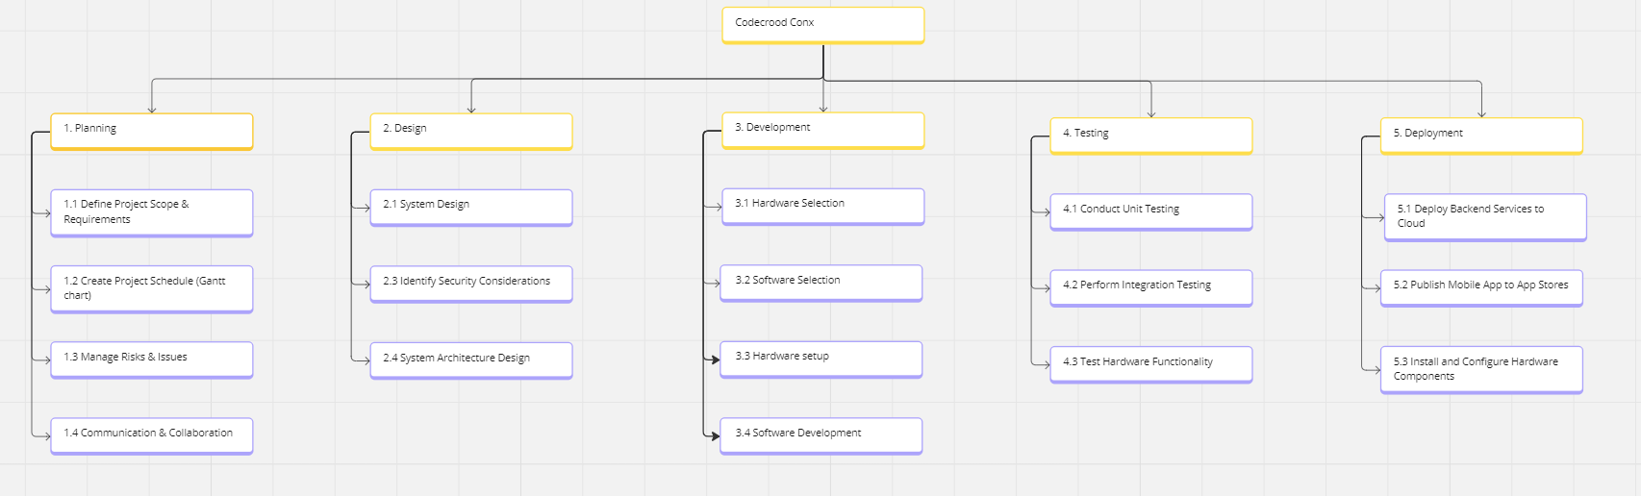

# 16. Gantt chart

## 16.1 Excel

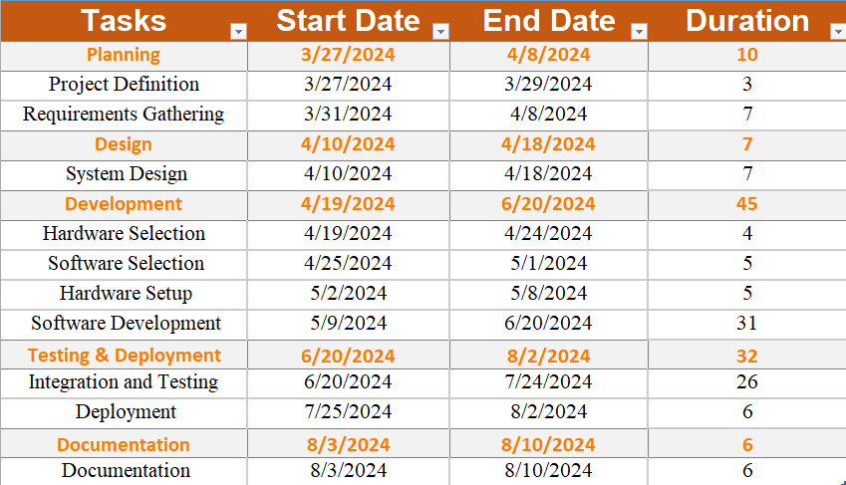

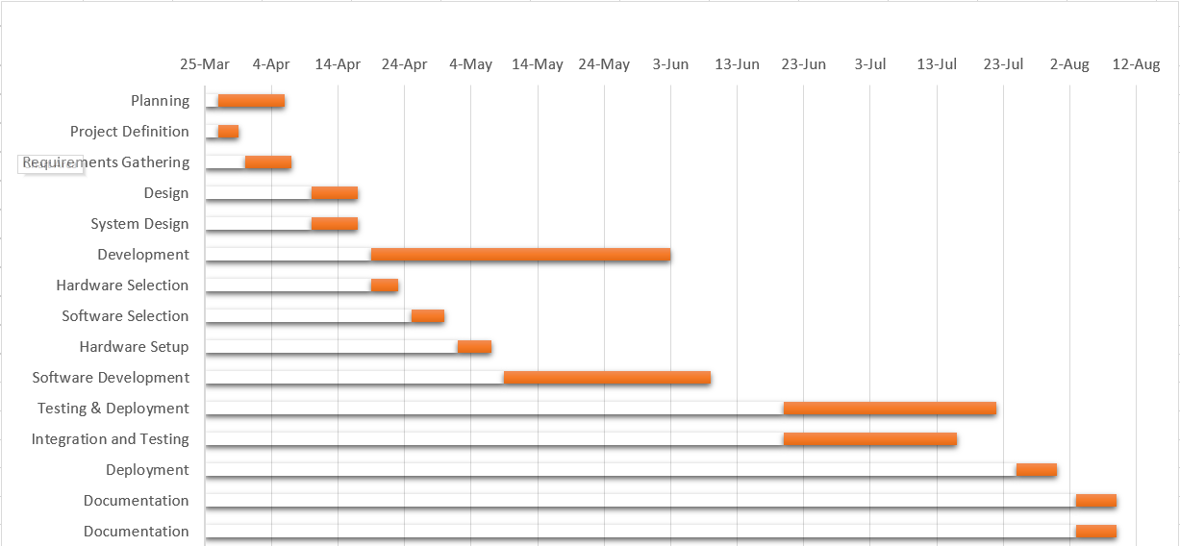

## 16.2 Microsoft Project

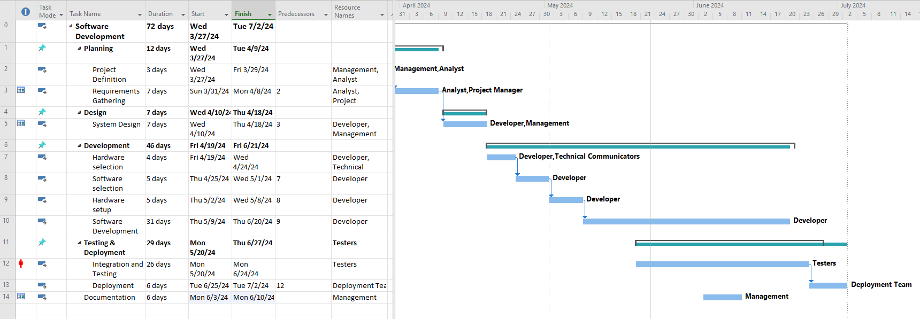

**17. Mockups**

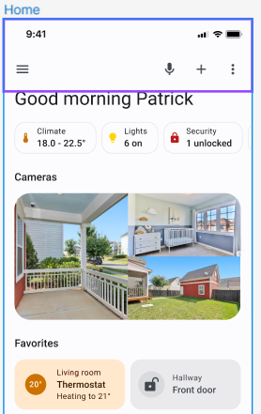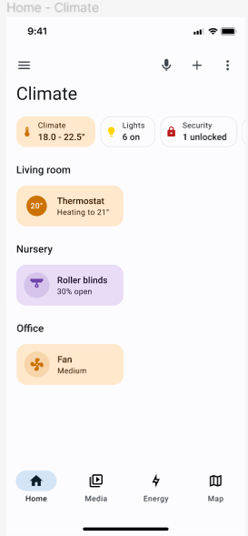

# 18. Conclusion

In conclusion, our proposed home automation project offers a comprehensive solution to enhance convenience, efficiency, and energy savings for users. By leveraging IoT technology, mobile app development, and hardware integration, we aim to create a user-friendly system that empowers users to control their home appliances remotely.

Through collaboration, learning, and dedication, our team is committed to delivering a high-quality product that meets the needs and expectations of our stakeholders. We look forward to the successful implementation and impact of our project in improving the daily lives of users.

**References**

1. <https://nodemcu.readthedocs.io/en/release/>
2. <https://www.figma.com/file/ZPRTON7huEj9kyXzPNxNgK/Future-concept?type=design&node-id=263-7391&mode=design&t=ao95ShGItuBTFUtn-0>
3. <https://reactnative.dev/docs/environment-setup>